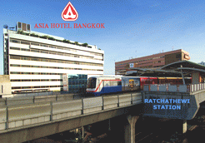
Asia Hotel Bangkok 296 Phayathai Road, in front of Ratchathewi SKYTRAIN Station, Bangkok 10400, Thailand

Room Type | Rate
Superior Single | 1,200 baht (include American breakfast)
Superior Twin | 1,400 baht (include American breakfast)

Mail to : MS. Thanaporn Thongchan,Sales Coordinator
Hotel requires a credit card guarantee by Amex, Diners, Visa, Mastercard or JCB to confirm your
reservation. Please mail to reservation by email to:navamon@asiahotel.co.th
and Attention : Thanaporn Sale with the following details:

 | Fight Schedule |  |  |  | Hotel Reservation
Participants | Arrival |  |  | Departure | Room Rate (+ABF) |  | Country
 | Date | Flight | Time |  | SGL 1,200 baht | TWN 1,400  baht | Country
First and Last Name

Remarks Extra Bed 600+ABF nett.

Accepted only for Credit Card of Bangkok Bank, MASTERCARD, and VISA Card.

Room Guarantee Policy - For a booking of 1-3 rooms, one night guarantee is required. For a group of 4 rooms or more, a non-refundable deposit of 50 % of total amount is required.
Cancellation Policy - For a booking of 1-3 rooms, 72 hours notice of cancellation is required otherwise first night will be charged. No refund for group cancellation.

